Department of Science and Humanities

F Y B Tech SEM II 2021-22
Engineering Physics Lab Course

Measurement of resistivity by 4-probe method
Name: Pargat Singh
Roll No: 16010121045
Branch: COMPS
Batch: A2

Aim: To determine the Energy Band Gap of Semiconductor

Apparatus:

- Container
- P-N Diode
- Battery
- Voltmeter
- Ammeter
- Thermometer

Diagram:

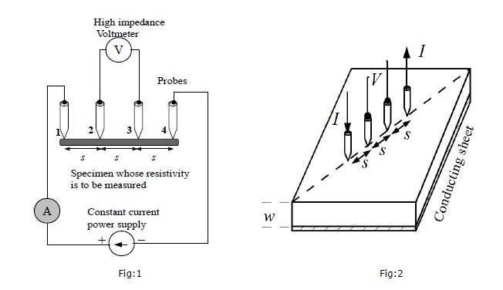

Observation Table:
Material: Germanium
Constant current = 10 mA

Temperature  (T) K | Voltage  (V) mV | Current  (I) mA | Resistivity*  (ρ) (Ω-m) | In(ρ) | $\frac{1}{T}$ (K⁻¹)
298 (RT) | 290.8 | 10 | 6.35 x 10⁻² | -2.76 | 0.336 x 10⁻²
303 | 282.2 | 10 | 6.01 x 10⁻² | -2.81 | 0.330 x 10⁻²
308 | 274.1 | 10 | 5.84 x 10⁻² | -2.84 | 0.325 x 10⁻²
313 | 266.5 | 10 | 5.68 x 10⁻² | -2.87 | 0.320 x 10⁻²
318 | 259.3 | 10 | 5.52 x 10⁻² | -2.90 | 0.315 x 10⁻²
328 | 252.5 | 10 | 5.38 x 10⁻² | -2.92 | 0.305 x 10⁻²
333 | 246.1 | 10 | 5.24 x 10⁻² | -2.94 | 0.300 x 10⁻²
338 | 240.0 | 10 | 5.11 x 10⁻² | -2.97 | 0.296 x 10⁻²
343 | 234.3 | 10 | 4.99 x 10⁻² | -3.00 | 0.292 x 10⁻²
*With geometric correction

Formula: resistivity (with geometrical correction factor) at a given temperature (T)
ρ $=2.13 ×{10}^{-3}\frac{V}{I}$
Home Assignment:
Plot a graph of ln(ρ) (Y-axis) v/s 1/T (X-axis). Determine its slope.
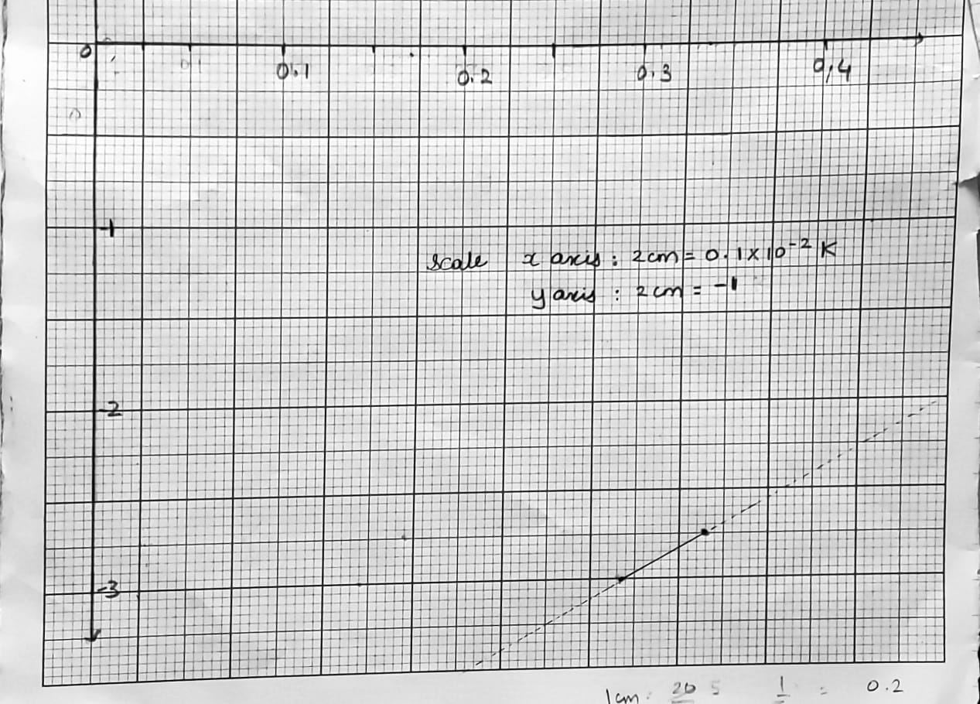
Calculate energy band gap using the formula: $E_{g}=2k×slope$; where k is Boltzmann constant = 8.62 x 10⁻⁵ eV/K.

Calculations:

Slope = 833.33
E_{g} = 2 x K x slope
Where, K is Boltzmann constant = 8.62 x 10⁻⁵ eV/K.
$∴$ E_{g} = 2 x 8.62 x 10⁻⁵ x 833.33 eV
= 14366 x 10⁻⁵ eV
= 1.44 x 10⁻ eV

Result:
Energy band gap of Ge = 1.44 x 10⁻ eV.

